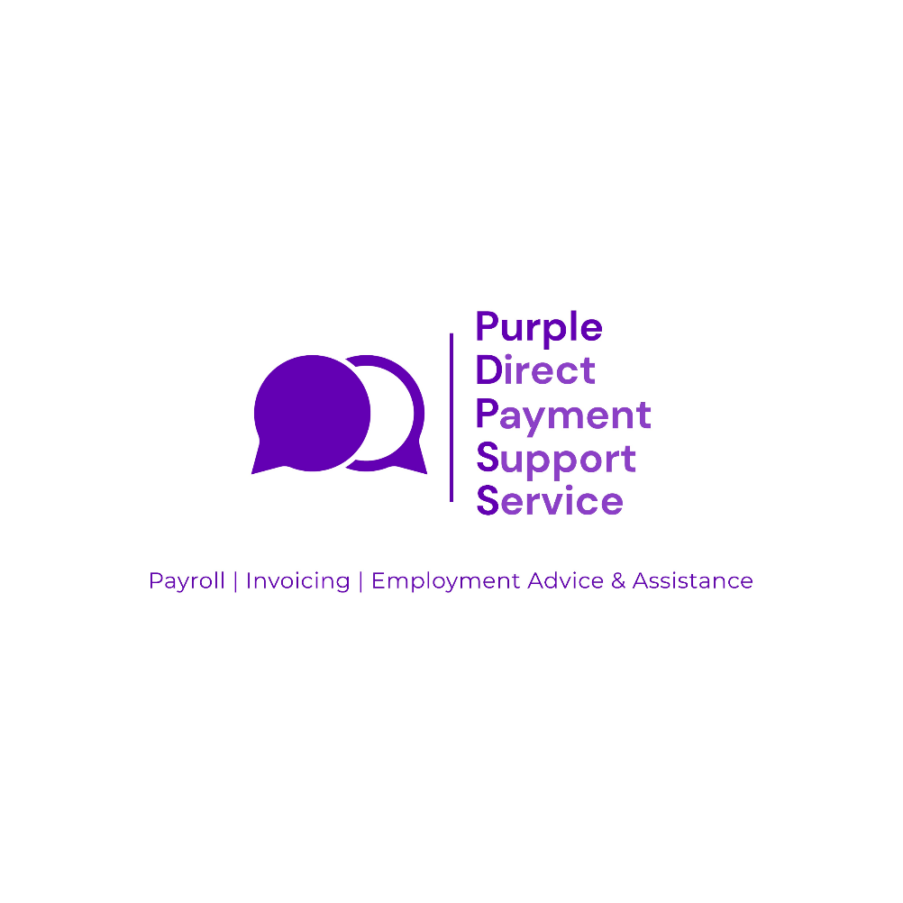

Sandwell

4 Weekly 1

Pay Day Timesheet Schedule

Please note the adjustment to the date the timesheet needs to be sent to Purple.

Timesheets for  4 weeks dates | Deadline by which they need to reach Purple by: | Pay Day
11/08/2024-07/09/2024  Last payroll with IFA | 10/09/2024  Last payroll with IFA | 13/09/2024  Last payroll with IFA
08/09/2024-05/10/2024  First payroll with Purple | 04/10/2024 by 12 noon  First payroll with Purple | 11/10/2024  First payroll with Purple
06/10/2024-02/11/2024 | 01/11/2024 by 12 noon | 08/11/2024
03/11/2024-30/11/2024 | 29/11/2024 by 12 noon | 06/12/2024
01/12/2024-28/12/2024 | 20/12/2024 by 12 noon  (Early due to Christmas Bank Holidays) | 03/01/2025

Please submit your timesheets by the deadlines above. Any timesheets received after the deadlines will be processed and paid on the next 4 weekly pay day. If necessary, please estimate your hours and adjust in the following pay period.

A further Timesheet Schedule for 2025 will follow in due course.

